Start by copying all of the codes into a new folder for the patient (in the Unix shell, not on Windows). We need separate folders for AP and PA.
E.g. folder should be called /home/tbi_clin/MC_codes /1234567_AP
(this is referred to as the ‘patient folder’)
The codes are here:
/home/tbi_clin/MC_codes/codes
The files that we need in the new patient folder:
- The patient egsphant from the tbi_clin account (e.g. 1234567_AP.egsphant)
- If egsphant doesn’t exist, export CT and RS again to
/home/tbi_clin/Patients/1234567_AP
and remake it (while you are in that directory) using the command:
phantom 1234567_AP
- The contourPoints file from the same folder (e.g. LOG.contourPoints or 1111.contourPoints)
- The Excel spreadsheet for the patient treatment (need to be available, don’t need to copy)
- The package of C++ scripts; only need to be recompiled if you changed the .cc file for any reason
We need to get some numbers from the egsphant – t0 coordinates, max_y_patient, and the grid dimensions
- Use dosxyz_show to see the x, y, z coordinates of t0 and max_y_patient (they are different from the corresponding Eclipse coordinates, due to offset of DICOM origin)
  - t0 is the treatment marker at the umbilicus (yz plane)
  - max_y_patient is the y-coordinate of the lowest part of the patient (look at xy plane)
  - Command is: dosxyz_show 1234567_AP.egsphant
  - Note: the display always says “x = 0.000, y = 0.000”, but it’s only actually x and y if you are on the “xy” grid display. If you are clicking yz, xz, then it actually means these variables.
  - Note: These values for max_y_patient and t0 can be measured in Eclipse, as long as y origin is at “field” origin, i.e. DICOM origin (not user origin). Note that t0 + max_y_patient = TC thickness (i.e. patient separation at TC), when adding absolute values. [this is not always true: the DICOM origin is not necessarily at the image centre in Eclipse]
- Grid dimensions: 0.25 cm, 0.25 cm and 0.5 cm in the x, y and z directions.
- From the Excel patient sheet, find the following items
  - MC_scaled z-values for t0, t1, t2.
  - Treatment time
  - Lung compensator thickness
  - Date of first treatment
  - Number of styros

Some phantom pictures:
Max_y_patient: use dosxyzshow to look at the patient CT and find the y-value of the couch by scrolling through the slices and finding the lowest value for y. (Use the XY-plane view) Round this value to closest 0.25 cm.
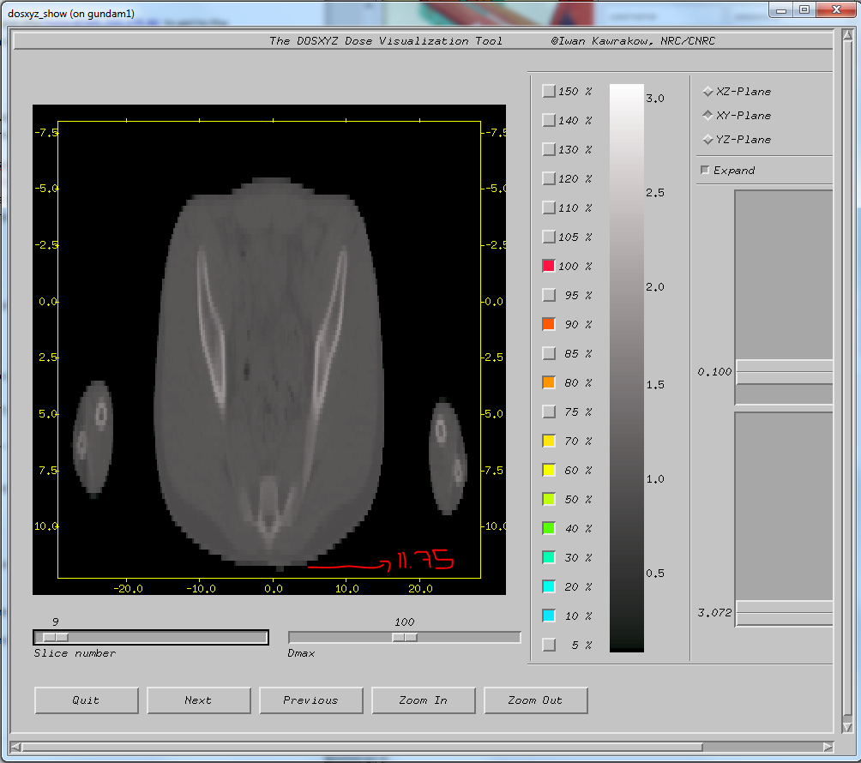

X,y,z coordinates of t0 in DOSXYZnrc for the patient (look in all three views so that you check each point twice, as a sanity check)
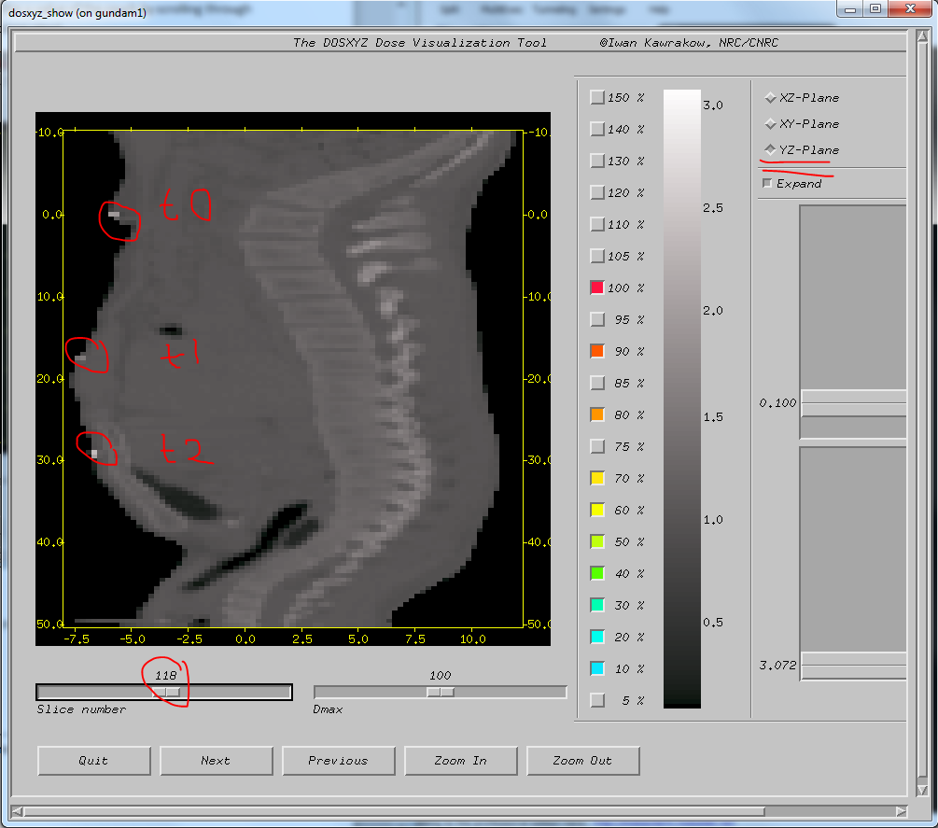
(I’ve circled all three points here so you can see them – but you only need to get t0 coordinates from this.)
Occasionally it can be hard to find the marker – not the end of the world if you’re off by ~0.1 cm, the resolution is only 0.25 cm anyway!
In one patient there was no t0 marker at all, so I made an estimate for its position based on t1 and t2 coordinates, and based on the coordinates in the Excel sheet.
In patient folder, open the file input_data.txt (with a text editor) and enter, one per line, the following information:
max_y_patient
number of styros
patient separation (TC thickness)
Save and close file.
First: type ./shift_calcs and press enter. It will output shift_y_tray, shift_y_lead, and SSD for the following calculations in the file output_data.txt, in the same folder.
We have to prepare .egsphant files for the lung compensators and the plastic tray. These need to have the right dimensions and the right geometry. We use quick scripts in python and Matlab for this:
Python
Make sure that the python code, read_and_scale_CPs_args.py, is in the same folder as the LOG.contourPoints file.
If the contourPoints file is named anything else, change the name of the file by using:
mv *.contourPoints LOG.contourPoints
Type this into the command line on the cluster:
python read_and_scale_CPs_args.py t0z t1z t2z (Use at least one decimal, including 0.0 for t0z; the value of t1z is not used)
These three values are the MC_Scaled values from the Excel sheet.
After running this Python script – you now have a .txt file, called contourstomask_res.txt
It will give you some warnings about some functions being deprecated. Don’t worry about them.
Matlab: (to open, type “matlab” in the cluster)
Use the code corresponding to the phantom that you are making (AP, Supine or PA, Prone):
mask_from_contours_2_AP.m
mask_from_contours_2_PA.m
Lines to change: from line 35 to line 45.
- xdim, zdim
  - The number of voxels in x and z (from line 10 of the egsphant; the first and third values)
- xmin, xmax, zmin, zmax
  - Get these values by opening the patient .egsphant and looking at the coordinate grid at the start – first and last values of the x-row and z-row
  - Enter them all as POSITIVE values!
- t2z_scaled: same as the value entered in Python
- compthick: the thickness of the compensator (see picture below of where to find it in Excel)
- 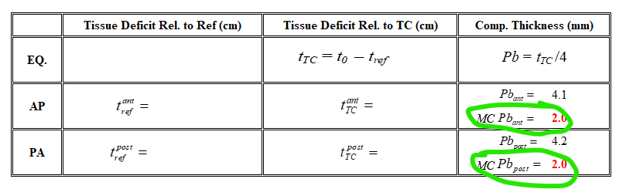
- tray thickness (e.g. 0.6)
After you run these scripts, Matlab will open a window with a picture of the compensators (they will be upside-down). You can close the picture and Matlab.
(Note: If they are blank, it’s because the L and R lungs were contoured in a different order by the rad onc (my code follows what they normally do, which is L then R). If this happens, all you need to do is open the .txt file that Python created (contourstomask_res.txt), and cut and paste the first two lines to the end of the file. This tells Matlab that the lungs are in the other order. Save it and run the Matlab script again.)
By now, confirm that you have three files in your working directory: the patient egsphant (1234567_AP.egsphant), the plastic tray (plastic3.egsphant), and lungcomps.egsphant.
C++:
Creating the complete egsphant file (patient + tray + comps):
Each of the codes produces a new .egsphant. You’ll want to delete the intermediate .egsphants when you finish with a patient in order to clear disk space.
Run the command
./puts_extend 1234567 AP shift_y_tray shift_y_lead extend_pixel
(extend_pixel is the number of pixels we want to extend in the inferior direction, for example, enter 4 if you need to extend by 1 cm [for a resolution of 0.25 cm])
However, for long phantoms (current CT protocol), extend_pixel = 0.

